A530-Mex-Colima-Figure-Male-Ithyphallic-Terra cotta-300 BCE-300 CE 

Figs. 1-2. Mex-Colima-Figure-Male-Ithyphallic-Terra cotta-300 BCE-300 CE

**Case No.: 9**

**Accession No.**

**Formal Label:** Mex-Colima-Figure-Male-Ithyphallic-Terra cotta-300 BCE-300 CE **Display Description:**

This figurine of a Colima ithyphallic male is both unusual and unexplained.

* **LC Classification:** F1219.1.C75

**Date or Time Horizon: 300 BCE-300 CE**

**Geographical Area: W Mexico**

**Map:**

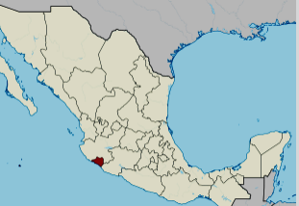

**Location of Colima, Mexico. https://upload.wikimedia.org/wikipedia/commons/thumb/a/a6/Colima_in_Mexico_%28location_map_scheme%29.svg/375px-Colima_in_Mexico_%28location_map_scheme%29.svg.png**

**GPS coordinates:** [19°10′N 103°53′W](https://tools.wmflabs.org/geohack/geohack.php?pagename=Colima&params=19_10_N_103_53_W_type:adm1st_region:MX)

**Cultural Affiliation: Colima**

**Medium: terra cotta**

**Dimensions:** 6" high

**Weight:**

**Condition:** original

**Provenance:** Originally deposited in a shaft tomb. Recovered from the ancient Colima culture in Western Mexico prior to 1970.

**Discussion:**

The Los Ortices period (500-300 BCE) established elements of the Colima culture, including shaft tombs and a distinctive ceramic style called *rojo bruñido,* or burnished red. The following Comala or Colima culture developed at the Comala site (300-300 CE). The Colima people perfected burnished red pottery *rojo bruñido* and produced terra cotta figurines of people and animals with distinctive fluid lines. The Comala site shows influence from Teotihuacan. Around 500 CE, another site in Armería developed along the river of the same name.

**References:**

Reynolds, Richard D. 1993. *The Ancient Art of Colima, Mexico*. Walnut Creek, Calif.: Squibob Press.